**User story of Hotel Management System**

**History Card**

|  |  |  |  |
| --- | --- | --- | --- |
| **Version#** | **Modification History** | **Update Date** | **Created/Reviewed by** |
| 1.0 | Create/Initial | 14th August4 2017 | Md. Rashed |
| 2.0 | Create/Initial | 22th August4 2017 | Md. Sanabeal Kabir |
| 3.0 |  |  |  |

Table of Contents

|  |  |
| --- | --- |
| **Project Name** | **2** |
| **Team Name** | **2** |
| **Team Members** | **2** |
| **Submitted to** | **2** |
| **Project Description** | **2** |
| **Current Scope** | **2** |
| **Future Work** | **2** |
| **User Story** | **3** |
| **Overview** | **3** |
| **1.user login** | **4** |
| **1.1 registration** | **5** |
| **2. user room information** | **6** |
| **3.user room reservation** | **7** |
| **3.1 booking details** | **8** |
| **4.admin login** | **9** |
| **5. admin room information** | **9-10** |
| **6.admin room reservation** | **10** |
| **7.booked room details** | **11** |
| **8. customer report** | **11** |
| **9.employee information** | **12** |

# **Project Name**

Hotel Management System

# **Team Name**

* **ARK three**

# Team Members

|  |  |  |  |
| --- | --- | --- | --- |
| SL# | Name | Email | Contact Number |
| 1 | Md. Rashadujjaman | sajalkhan625@gmail.com | 01638008030 |
| 2 | Md. Sanabeal Kabir | [sanabealkabir@gmail.com](mailto:sanabealkabir@gmail.com) | 01832255918 |
| 3 | Ahash Roy |  | 01670881084 |

# 

# Submitted to

|  |  |  |  |
| --- | --- | --- | --- |
| SL# | Name | Email | Contact Number |
| 1 | Md. Mahedee Hasan | [Mahedee.hasan@gmail.com](mailto:Mahedee.hasan@gmail.com) | 01755618129 |

# 

# Project Description

Hotel Management System is a web based application that will represent a Hotel’s management system that will have Room information, room reservation system, employee’s information, and individual customer reports. A user can do advance booking through online.

Current Scope

Our current scope is to add room reservation to the system. Add room information system. Also have a current and advance room booking and payment by various way. Also have employee information assigned to each room for services.

Future Work

We will develop the other aspects of a hotel management system such as hotel expenses and earnings calculation system.

# User story

|  |  |  |
| --- | --- | --- |
| **SL** | **Admin Panel** | **User Panel** |
| 1 | Admin login | View Room Details |
| 2 | Room Type | Room reservation for Clients |
| 3 | Room Category | Report Generation for Clients |
| 4 | Room information |  |
| 5 | Price Setup |  |
| 6 | Room reservation |  |
| 7 | Payment |  |
| 8 | Report Generation |  |

Overview

Here we have presented the overview of our proposal where the homepage is contained with eight stories including **Home, services, admin login, and user login, register, contact us.** A user can easily know the room information and can also reserve room by user login. Admin can reserve room for customer, see room information, booked room details, individual customer report and also employee information by admin login.

1. User Registration :

Registered users normally provide some sort of credentials (such as a username or e-mail address, and a [password](https://en.wikipedia.org/wiki/Password)) to the system in order to prove their identity.

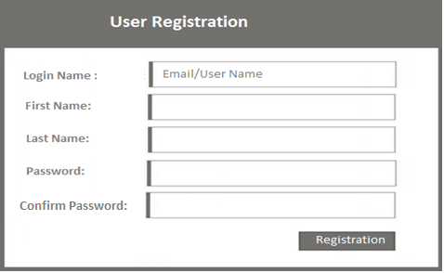

1. Login:

In computer security, logging in is the process by which an individual gains access to a system by identifying and authenticating themselves.

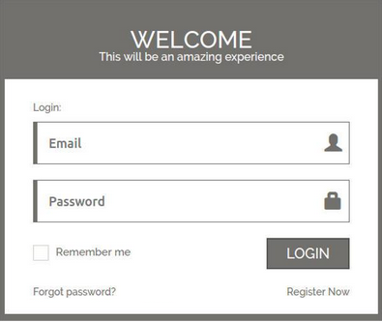

1. Room Facilities:

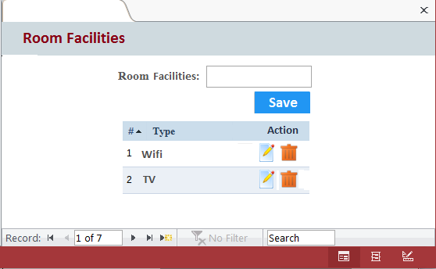

1. Room Type:

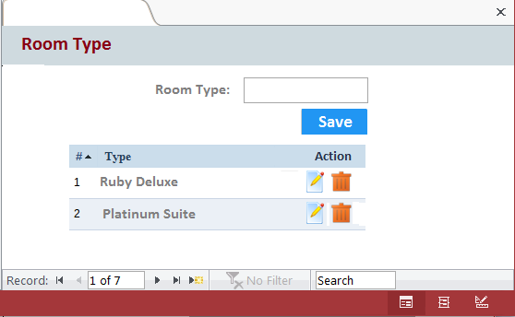

1. Type Wise Facility:

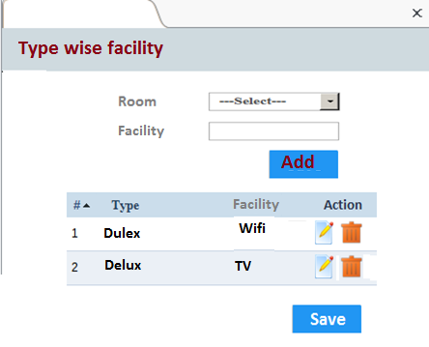

1. Room Information:

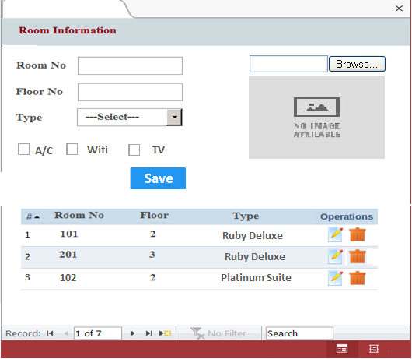

1. Price Setup:

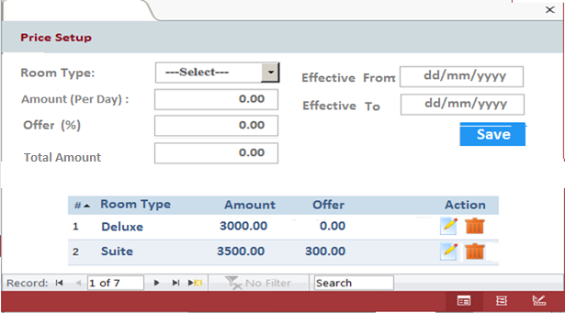

1. Room Reservation:

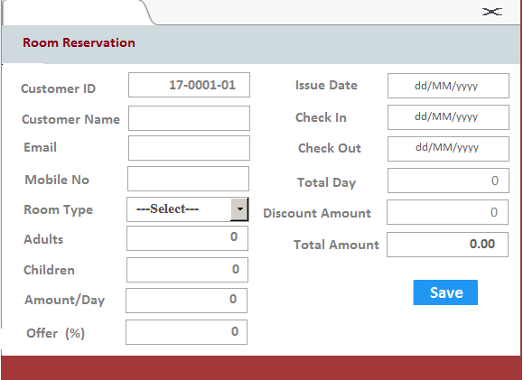

1. Payment:

Dropdown list show customer (Email+MobileNo) for remove duplicate customer.

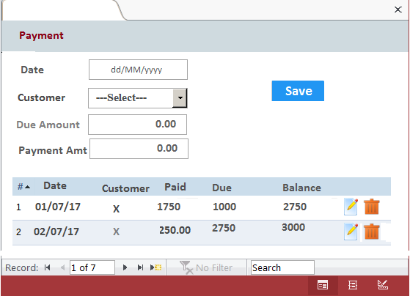

1. Report Generation:

In this function reports are generated for the following entities:

1. **Customer Details.**

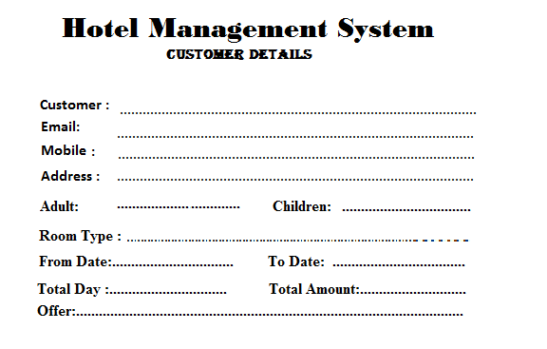

1. **Rooms Details**

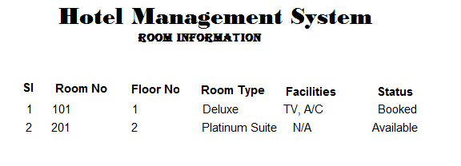

1. **Bill Details**

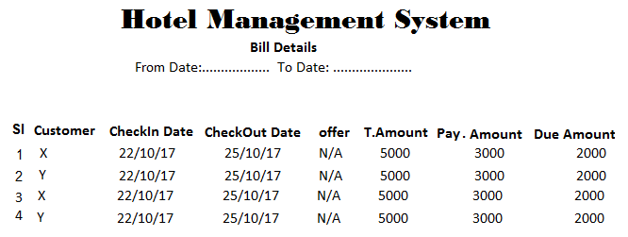

**d) Booking Details**

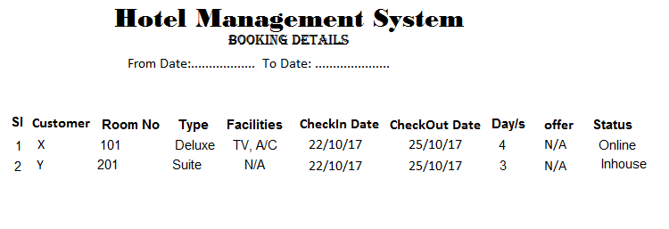

1. User Panel :

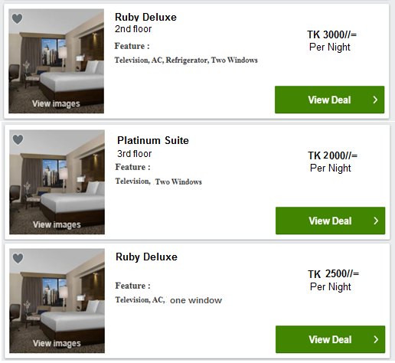

1. Room reservation:



1. Report Generation:

In this function reports are generated for the following entities:

a) Customer Details.

c) Rooms Details

d) Bill Details